The Big Day Family Style
P.o.c.: Bill, Peggy & Sara
June 5, 2010 /////////// 280 Guests
304 SEATING AND FOOD

 Classic Southern Family Style Dinner 

Menu set 4-30-10 wrp& LAURA& Sara
Hovers
Caramelized Pineapple with Vanilla Scented Mascarpone, White Truffle Fromage
Apple-wood Smoked Bacon Crisp with aged Parmesan Cheese, Bruschetta with Balsamic Reduction and fresh Basil, Mini Pork Slider’s

Family Style served in separate course—changed per Lara -
Fresh Citrus Wedge Salad with Poppy Seed Dressing

Entrees’
Balsamic Glazed Flank Steak& Soaked Mushrooms
Pancko Crusted Chicken Breast with over Milk Cream Gravy

Classic Mac & Cheese, Garlic & Rosemary Roasted New Potatoes
Sautéed Red Pepper onion and Kernel Corn, Fried Green Bean Casserole
Biscuit with Butter and Jelly

Dessert Course:
Wedding Cake by Bliss

Beverages:
B&B Signature Water & Iced Tea with Lemon, Cheerwine on Ice
Specialty Drink – Non-Alcohol Mango Infused Lemonade & Sweet Tea Vodka Lemonade Cocktail (Arnold Palmer with Alcohol)
~

- Seating tables 19. 16 tops x 19 = 304
FOOD PLATTER / QTY UNTESIL / QTY
CHIX– BEEF 40 EACH LONG PLAT FORK 40 / TONG 40
MAC CHEESE 40 EACH BOWL SPOON 40
CORN 40 EACH BOWL SPOON 40
GB 40 EACH BOWL SPOON 40
POT 40 EACH BOWL SPOON 40
SALAD 40 EACH LONG PLAT TONGS 40
BISCUTS 40 EACH LONG PLAT TONGS 40
BUTTER 40 WHT. SALAD PLATE TEA SPOON 40
JELLY 40 SMALL WHT. BOWL TEA SPOON 40
POP DRES/SHOTGLAS 40 EACH LONG PLAT

- TOTALS = 5 platters/bowls etc. are automatically added to each total

LONG PLATTER WHT. (SIZE) 170 EACH
WHT. BOWL MED SIZE 170 EACH
TONGS 170 EACH
SPOONS / LG. MED. 170 EACH
SMALL JELLY/BUTTER BOWL 76 EACH
TEASPOONS 76 EACH
FORKS 40 EACH

- B&B doing Ind. Food name tags for each food item.

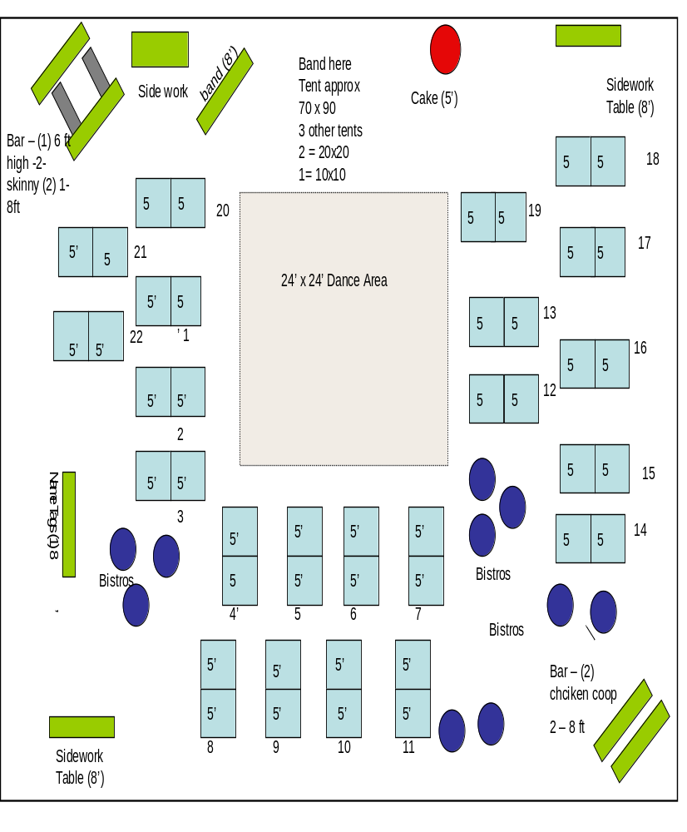
Ross-Kinzie 5-5-12
Salad & Entrée One Course – 2 - 5 ft sq.

CROQUETS
WHT SQ CHINA
SPATULA 1
CHIX
BLK SQ. CHINA
1 tongs


SALT AND PEPPER

FILET
BLK MELAMINE
1 tongs

VEG.
WHT SQ. CHINA
1 tongs

Tom salad
Wavy bowl Wht
Blk 7 ‘riser
TBL SPOON
Bread / Silver basket / napkin
Tongs

Butter, bb rarebit
Teaspoon
Tom salad
Wavy bowl Wht
Blk 7 ‘riser
TBL SPOON
Bowl
1 serving spoon

CHIX
BLK SQ. CHINA
WHT RISER
1 tongs

CROQUETS
Wht SQ CHINA
SPATULA 1

Bread / Silver basket / napkin
Tongs
1 tongs

SALT AND PEPPER

VEG.
WHT SQ. CHINA
1 tongs
FILET
BLK MELAMINE
1 tongs

Butter, bb rarebit
Teaspoon

Bowl
Serving spoon



